**Assignment 01**

Q1:-

Ans: Single thread :-

Single threaded processes contain the execution of instructions in a single sequence. In other words, one command is processes at a time.

Synchronous vs Asynchronous

In synchronous operations tasks are performed one at a time and only when one is completed, the following is unblocked and in Asynchronous task can be performed simultaneously depending on time taken for the execution by the interpreter.

Q2:-

Ans:- Global Execution :

When the JavaScript interpreter initially executes code, it first enters into a global execution context by default. Each invocation of a function from this point on will result in the creation of a new execution context.

JS engine:

It’s a interpreter which executes the javascript code.

Q3:

Primitive vs non-premitive

Data type that can not be broken be more smaller units is called primitive data type for example int and char..etc

Types of data type in JS:

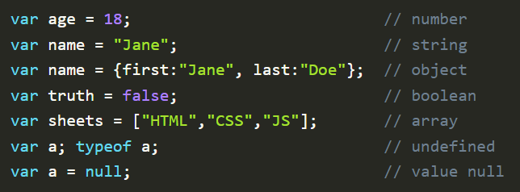

First program using primitive data type

